Chapter 18: Inferences about Means

1. **Confidence Interval for Means:**

**2004 Farmed Salmon Example:**

1. Open a new excel sheet.
2. Use **CONFIDENCE.T** function to calculate the margin of error.



where **alpha $\left(α\right)$** is the significant level. A significant level 0.05 indicates a 95% confidence level.

**standard_dev** is the standard deviation of the population. We may use the sample standard deviation as an approximation.

**size** is the sample size (n).

1. Using the textbook example: sample size (n) = 150, sample mean ($\overline{Y}$) = 0.0913, sample standard deviation = 0.0495 and we need a 95% confidence interval.

|  |  |
| --- | --- |
| Sample Size (n) | = 150 (given) |
| Sample Mean ($\overline{Y}$) | = 0.0913 (given) |
| Sample Standard Deviation (S) | = 0.0495 (given) |
| Confidence Level (1 - α) | = 0.95 (given) |
| Significant level (α) |  |
| Margin of Error (ME) |  |
| Lower Confidence Level (L) |  |
| Upper Confidence Level (U) |  |

1. The result is

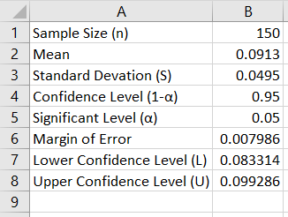

The 95% confidence interval is (0.083, 0.0993)

1. **A Hypothesis Test for the Mean:**

**DMV Example:**

1. Open a new excel sheet.
2. Use **T.DIST** function to calculate the p-value. There are two versions of this function which are





where **x** is the T score (test statistic). Deg_freedom is the degrees of freedom which is (sample size - 1). Tails are the number of distribution tails; tails = 1 for one tail (side) and tails = 2 for two tails (sides). If “cumulative” = TRUE, the area under the curve to the left of “X” is returned. If “cumulative” = False, the height of the curve at “X” is returned.

1. Using the textbook example: sample size (n) = 90, number of who passed = 61.

|  |  |
| --- | --- |
| Hypothesized Value ($μ_{0}$) | = 0.08 (given) |
| Sample Size (n) | = 150 (given) |
| Sample Mean ($\overline{Y}$) | = 0.0913 (given) |
| Sample Standard Deviation (S) | 0.0495 |
| SD ($\overline{Y}$) |  |
| Significant Level ($α$) | 0.05 |
| Degrees of Freedom (df) |  |
| T score |  |
| P-value |  |

1. The result is

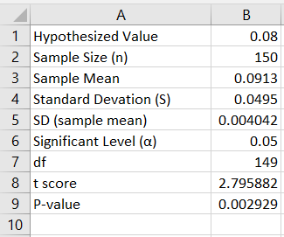

**Note:**

1. If $H_{a}:μ<μ_{0}$, then use P-value = T.DIST (t, df, True)
2. If $H_{a}:μ>μ_{0}$, then use P-value = T.DIST.RT (t, df)
3. If $H_{a}:μ≠μ_{0}$, then use P-value = T.DIST.2T (t, df,)